https://www.odu.edu/news/2021/11/intel_oneapi#.Y0docP1ByUl



# ODU Establishes oneAPI Center of Excellence to Optimize NASA Research

November 08, 2021

The Department of Computer Science at Old Dominion University (ODU) is establishing an Intel oneAPI Center of Excellence that focuses on optimizing unstructured-grid computational fluid dynamics (CFD) kernels on Intel central processing units (CPUs) and Xe graphics processing units (GPUs) at NASA Langley. The research will be led by Mohammad Zubair, a professor in Computer Science, to use oneAPI to develop efficient implementations that can run on diverse architectures and help solve some of the most complex aerodynamic challenges.

oneAPI is an open, unified, cross-architecture programming model for CPUs and accelerators. Being an open industry standard, oneAPI simplifies software development on multi-architecture systems and helps developers deliver productive, performant single source code that can be maintained more efficiently.

ODU is on a growing list of universities to establish a oneAPI Center of Excellence. "Besides performing research and technology advances, ODU will train master of science and doctoral students in cross-architecture programming using oneAPI," said Zubair. "We also plan to include oneAPI modules in our ODU graduate-level courses for accelerating high-performance computing."

A diverse array of new hardware architectures continues to emerge across the high-performance computing (HPC) landscape. "As a result, the application developer is faced with the considerable challenge of providing near-optimal performance across these systems," said Zubair. "This goal requires a detailed understanding of each target architecture, and some means to accommodate specific data layouts and algorithm implementations that map appropriately."

"Professor Zubair has been an innovative leader in high performance computing for many years," said Gail Dodge, dean of ODU College of Sciences. "Establishing an Intel oneAPI Center of Excellence in this area will enrich and expand ODU's collaboration with NASA Langley."

"Professor Zubair is an expert in HPC and has been working closely with NASA Langley to port and optimize large-scale CFD applications on emerging HPC architectures," said Ravi Mukkamala, chair of ODU Computer Science. "Since 1990, he has been a pioneer in establishing graduate and undergraduate courses in HPC, and he has played a critical role in developing and optimizing CFD algorithms for GPU architectures."

The proposed oneAPI center will address several of NASA's most difficult computational challenges, especially fluid dynamics applications and software routinely applied to the nation's most complex operating system. This includes supersonic simulations, as well as hypersonic and reentry configurations for launches together with broader science and engineering efforts both inside and outside NASA.

"ODU has a strong history of collaboration with NASA on projects of mutual interest, such as the exploration of emerging HPC architectures for NASA's widely used FUN3D computational fluid dynamics application," said Beth Lee-Rausch, branch head, computational aeroSciences at NASA Langley Research Center. "We look forward to continuing these collaborations, and we are excited to work with ODU's oneAPI Center of Excellence."

"We're excited that ODU and NASA will use oneAPI programming avoiding constraints of proprietary models and achieving full performance from their accelerated computer hardware. ODU's oneAPI Center of Excellence will also train students and help grow the oneAPI ecosystem," says Joe Curley, vice president and general manager of Intel Software Products and Ecosystem group.

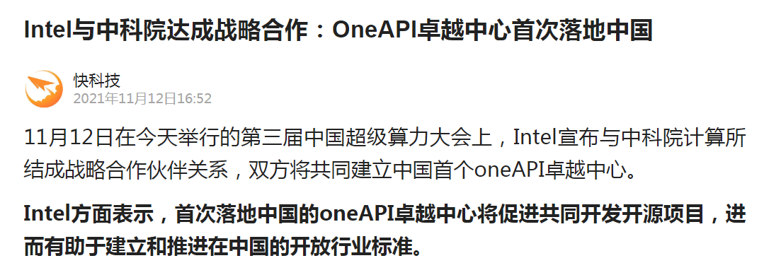

Intel全新Xe架构GPU大曝光：性能是NVIDIA安培A100的2.2倍。

2020年8月13日，芯片业巨头Intel在0202架构日活动里正式宣布了全新自研Xe架构GPU，并将其细分为四大级别： Xe_LP、Xe_HP、Xe_HPG和Xe_HPC。这其中，HPG作为支持硬件级光线追踪的型号，将面对发烧级硬件玩家，此举也让双雄争霸的显卡市场终于迎回了“老面孔”。

那么，在CPU领域称王称霸的Intel做显卡到底是什么水准呢？

虽然Xe系列GPU还没有发售，但其具体规格已从各种渠道留出。具体来说，Xe_HP的封装规模有1Tile、2Tile和4Tile三种，其中1 Tile集成512组EU单元，每个EU为8核，所以总计4096核心，以此类推，4 Tile就是16384核，核心频率可以达到1.3GHz。

据Intel官方数据显示，4 Tile的FP32（单精度）浮点性能居然达到了42 TFLOPS，号称目前单芯片全球第一。相较于1 Tile的10588 GFLOPS，放大比是3.993：1，比传统意义上的双芯显卡、多卡互联比起来，效率简直夸张。

事实上，以上成绩就算在面对NVIDIA的安培A100核心时，也占尽了优势。作为NVIDIA最新主打的GPU芯片，安培A100主频1.41 GHz左右，内建6912个CUDA核心，单精度浮点约19.5 TFLOPS。